

**Explanation:-**

Created a reference named **‘a’** and referred the file named Employee_Expense.txt.



Loaded the file that is referred by **‘a’** using dump command.



Please find the output of **“dump a”** below.

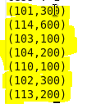

Created a reference named **‘b’** and referred the file named Employee_Detail.txt.



Loaded the file that is referred by **‘b’** using dump command.



Please find the output of **“dump b”** below.

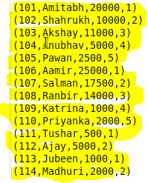

We have joined relation a and relation b with the help of empid in relation a and field named id in relation b and joined relation is referred by relation c so that **we can get the details of employees who has entry in Employee_Expense.txt.**

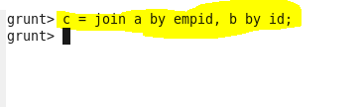

Loaded the file that is referred by **‘c’** using dump command.



Please find the output of **“dump c”** below.

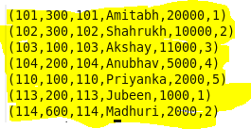

Now we need to display the empid and name of those employees who has entries in Employee_Expense.txt. So, **we are generating empid and name for each row in relation c** and is referred by relation named **res.**



Loaded the file that is referred by **‘res’** using dump command.



Please find the output of **“dump res”** below.

